Carteret General Hospital
(Carteret Health Care)
PHARMACY RESIDENCY INFORMATION SESSION
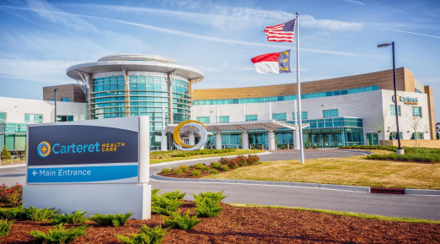
Please join us on a virtual meet-and-greet to learn all about our residency program!

What to Expect:
After you register for the meet-and-greet, you will receive an email from the two current residents. There will be a short overview of our residency program at the beginning, where the residents, residency director, and clinical coordinator will discuss the unique qualities that Carteret Health Care has to offer. The remaining time will be open for any questions you have regarding our program.

How to Register
Please register for a meet-and-greet session by using one of the following links:
Monday, November 15th from 6:00 – 7:00pm
Tuesday, November 16th from 6:00 – 7:00pm
Monday, November 22nd from 6:00 – 7:00pm

Click the link below to view a virtual tour of our pharmacy!
CHC Pharmacy Tour

Please email us if you have any additional questions at:
hndavis@carterethealth.org or kawieder@carterethealth.org
Please visit our Pharmacy Residency website for more information on our program:
https://www.carterethealth.org/careers/pharmacy-residency/

3500 Arendell Street, Morehead City, NC 28557

